USER GUIDE
- Admin Guide
- Login :
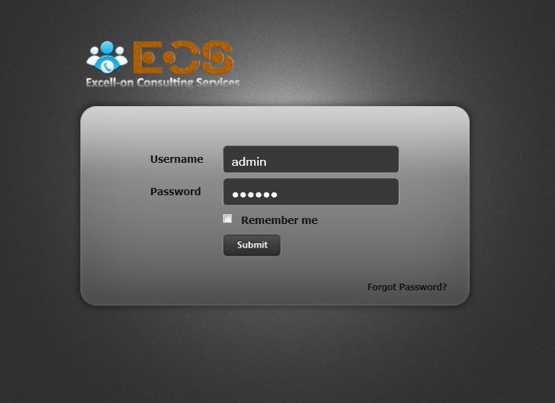
Enter your username & password !
If forgot password, click to link “Forgot your 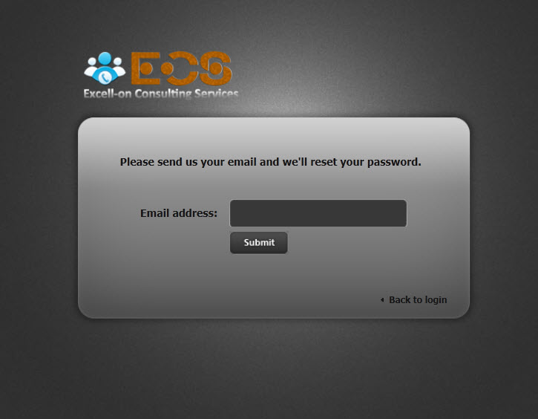
Enter your email ,if email exits in system, password will sent to your email.
Check you mail, you can see password !
- Account manager

Click to account list in left menu, all account in system will display
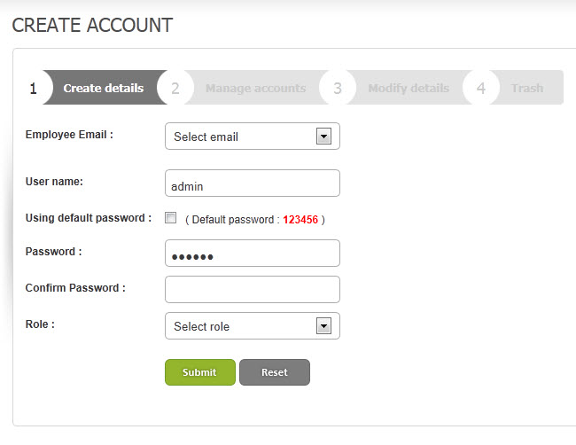
For create account, you must input all information of account, password will sent to mail register
- Department
a, Department manager
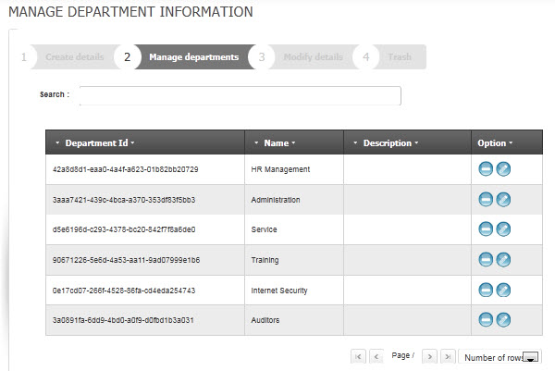
b, Create department
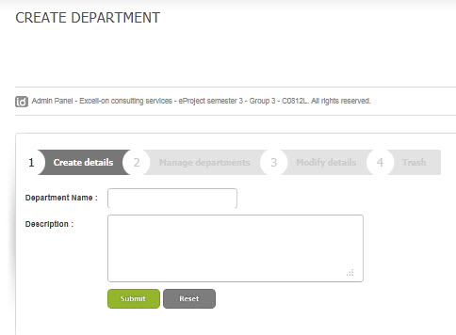

Add new a depart ment when you click “Submit” and cacel when you click “Reset”.
c, Update Department
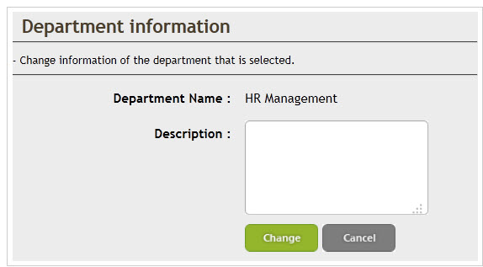
When you click change then information of department updated
d, Trash of department
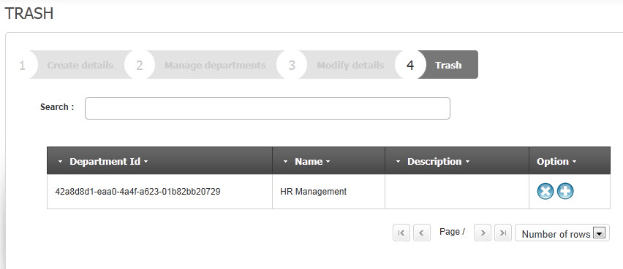

There records removed will be displayed here
- Employee
a, Manager Employee
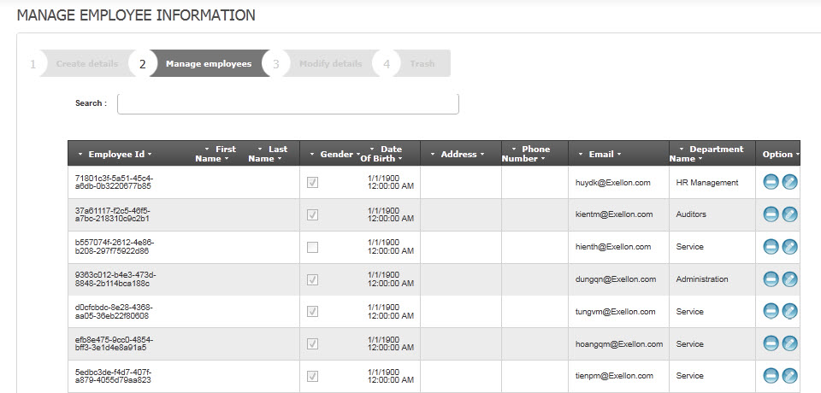
Show all records
b,Insert employee
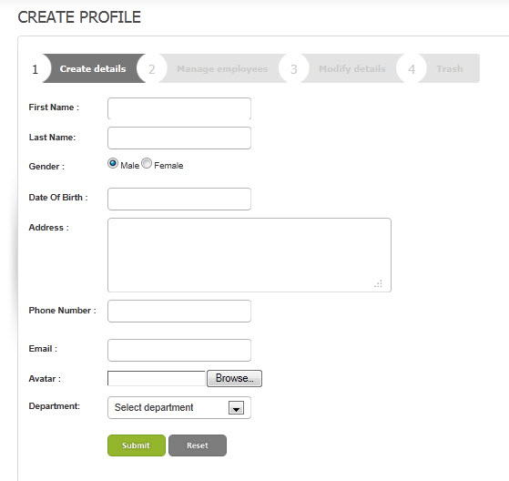
To add new Employee, click button “Submit”. After input information, click button “OK” to insert to database, click reset to clean all text box and click button “Cancel” to cancel 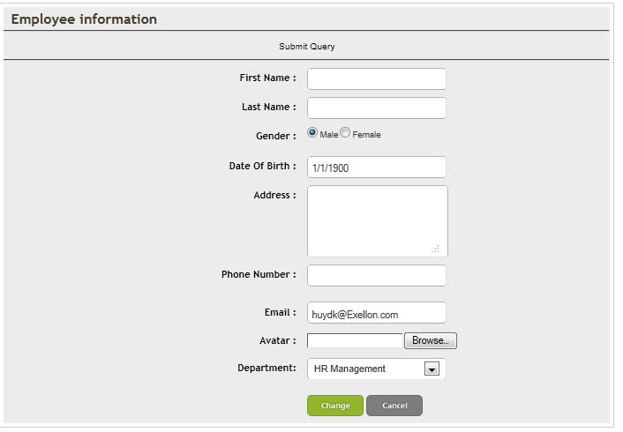
To edit Account, user choice “Edit”. After edit information, click “Update” to update to database,or reset for return original information and click “Cancel” to cancel.
d,Trash employee
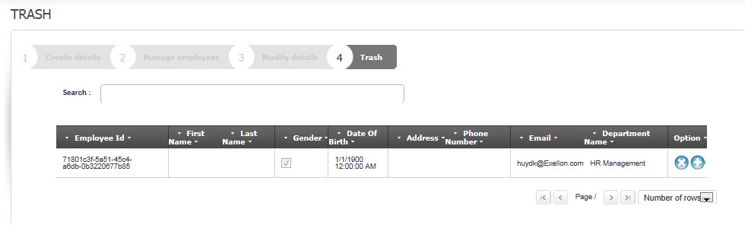
To delete a employee user need to mark items checkbox, which corresponding to the line has employee,who need to delete , then click the delete button.
e,Search Employee
To search a employee, user need enter string to seach,after choise methods search, example search by name,email,address... then click the Search button.
- Dealer
a,Insert dealer
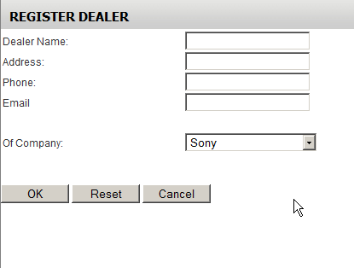
To add new dealer, click button “Insert”. After input information, click button “OK” to insert to database, click reset to clean all text box and click button “Cancel” to cancel and return dealer List.
b,Update dealer
To edit dealer, user choice “Edit”. After edit information, click “Update” to update to database,or reset for return original information and click “Cancel” to cancel.
c,Delete dealer
To delete a dealer user need to mark items checkbox, which corresponding to the line has dealer,who need to delete , then click the delete button.
d,Search dealer
To search a Dealer, user have two way to do. The first way, user need enter string to seach,after choise methods search, example search by name,email,address... then click the Search button. The second way, user use filter funtion to search dealer follow company name.
- .Company
a, Manage Company
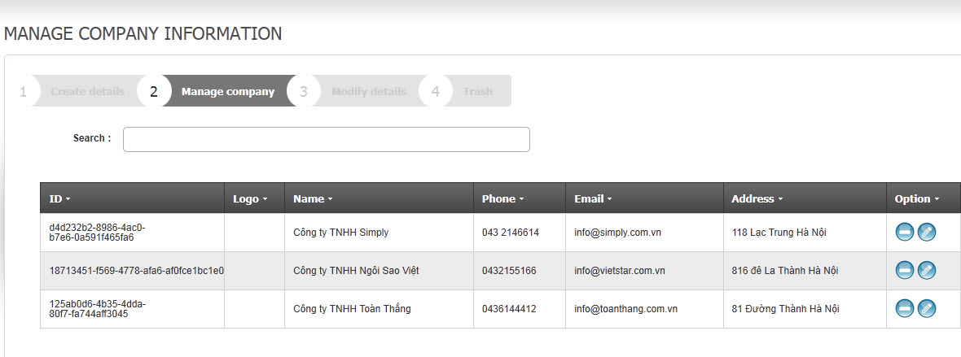
Show all records
b,Insert company
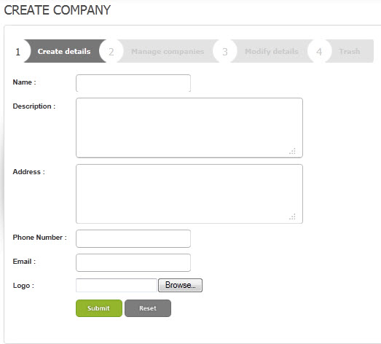
To add new company, click button “Insert”. After input information, click button “OK” to insert to database, click reset to clean all text box and click button “Cancel” to cancel and return dealer List.
c,Update company
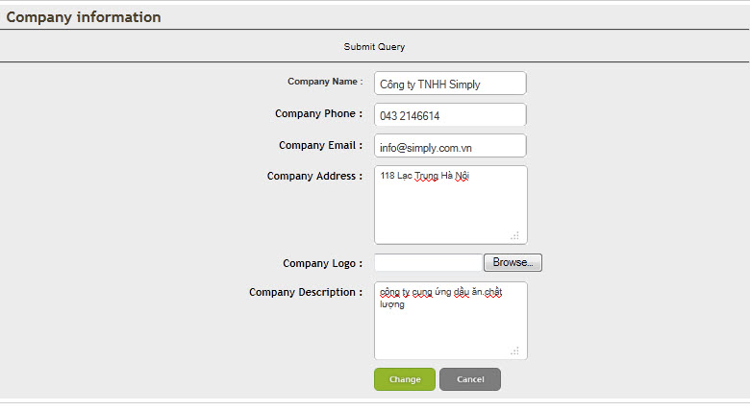
To edit company, user choice “Edit”. After edit information, click “Update” to update to database,or reset for return original information and click “Cancel” to cancel.
.
d,Trash Company
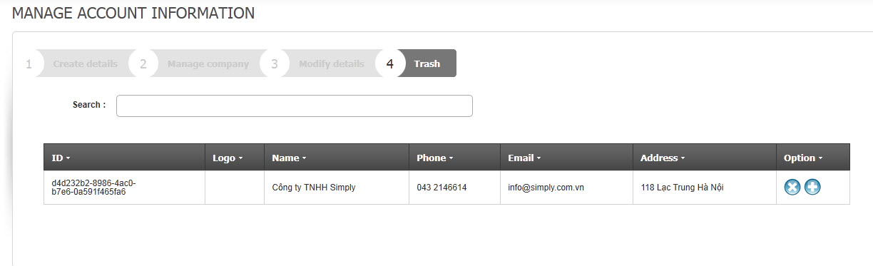
8.Product
a, Manager product
Show all records
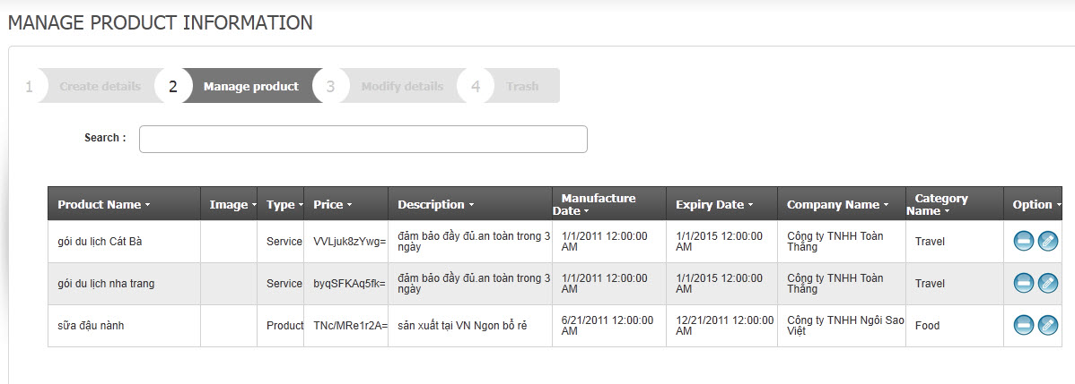
a,Insert product
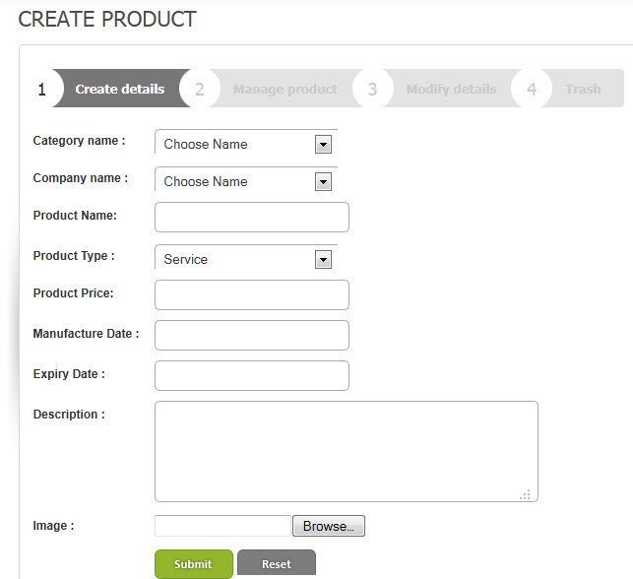
To add new product, click button “Insert”. After input information, click button “OK” to insert to database, click reset to clean all text box and click button “Cancel” to cancel and return dealer List.
b,Update product
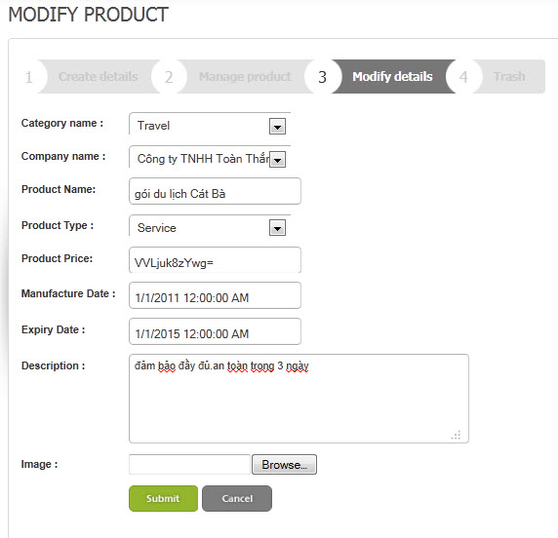
To edit product, user choice “Edit”. After edit information, click “Update” to update to database,or reset for return original information and click “Cancel” to cancel.
c,Delete product
To delete a product user need to mark items checkbox, which corresponding to the line has product,who need to delete , then click the delete button.
d, Trash product

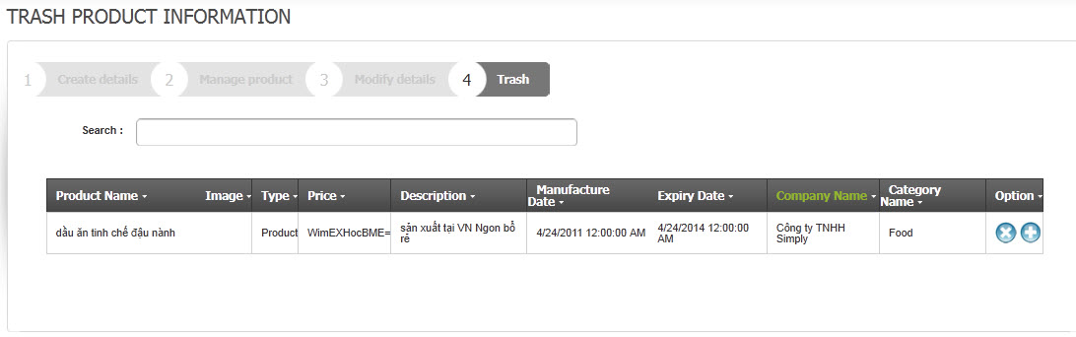

9. Problem
a, Manager problem
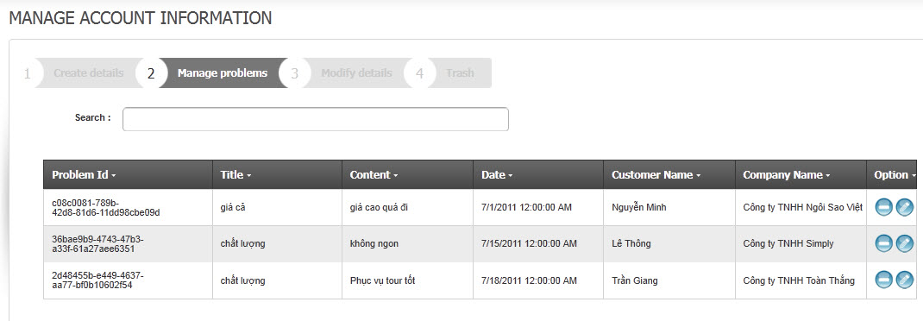
Show all records
b, create problem
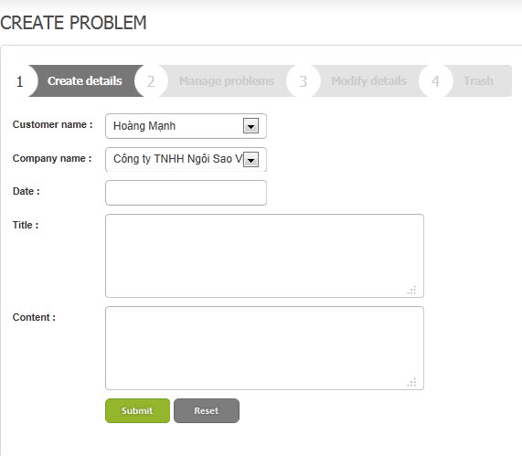

When you click “Submit” then insert to database 1 records, click “Reset” then cacel.
c, Modofy problem
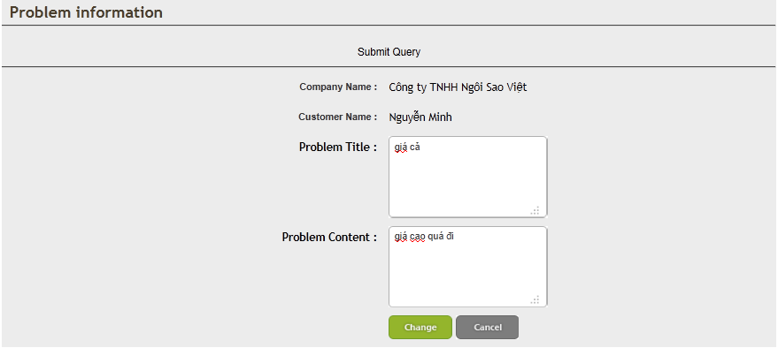
Update infortion for problem
d, Trash problem
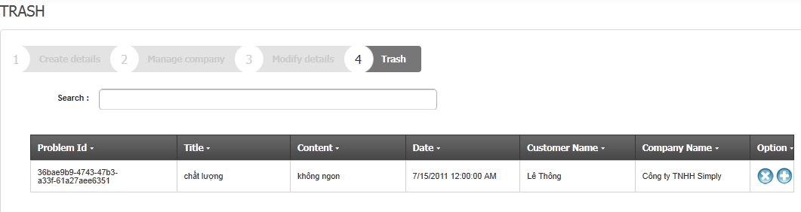
10. Order
a,Manager order
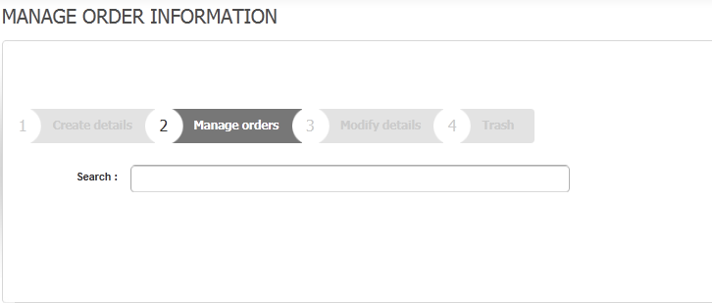
Show all records
b, Create order
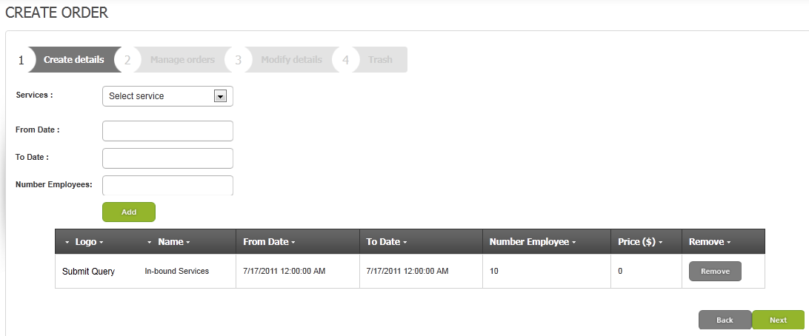
c, details order
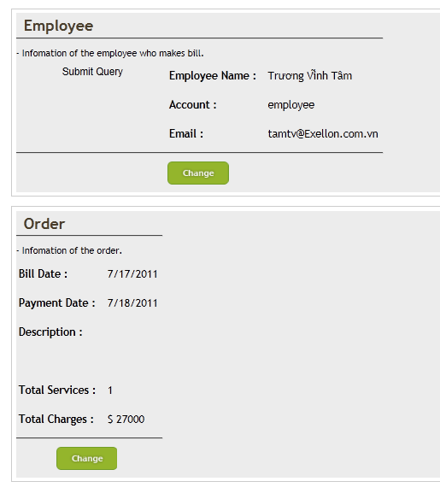

11.Service
Create service
